Strategic Product Placement Sales Impact Analysis: Final Report
Project Name: Strategic Product Placement Analysis
Date: 18 January 2026
Team ID: LTVIP2026TMIDS89175
Team Size: 5
Team Leader: Shaik Fazarunnisa Begum
Team Member : Somineni Niharika
Team Member : Hema Vishnu Vardhan Ankireddy
Team Member : Yallavula Amulya
Team Member : Vinjamuri Anil Kumar
College: Rise Krishna sai prakasam group of institution
1. INTRODUCTION
1.1 Project Overview
The Strategic Product Placement Sales Impact Analysis project aims to study how product placement within stores or digital shelves affects sales volume. Using data visualization and analysis, this project helps businesses optimize product positioning to maximize sales and customer engagement.
1.2 Purpose
The purpose of this project is to:
- Understand the relationship between product positioning and customer purchasing behavior.
- Identify key placement strategies that enhance sales.
- Support data-driven decisions for retail layout and e-commerce UI design.

2. IDEATION PHASE
2.1 Problem Statement
Key Pain Points:
- Retailers lack visibility into how shelf positioning impacts sales.
- Production studios struggle to quantify brand engagement from placements.
- Ad agencies can’t correlate placements with consumer behavior.
Formal Problem Statements (PS):
- "I am a retail manager trying to optimize shelf layouts, but I rely on guesswork because I lack real-time placement analytics."
- "I am a TV producer trying to monetize product placements, but I can’t measure audience engagement because data is siloed."
- "I am a media planner trying to prove placement ROI, but I can’t link exposures to sales lifts because tracking is fragmented."

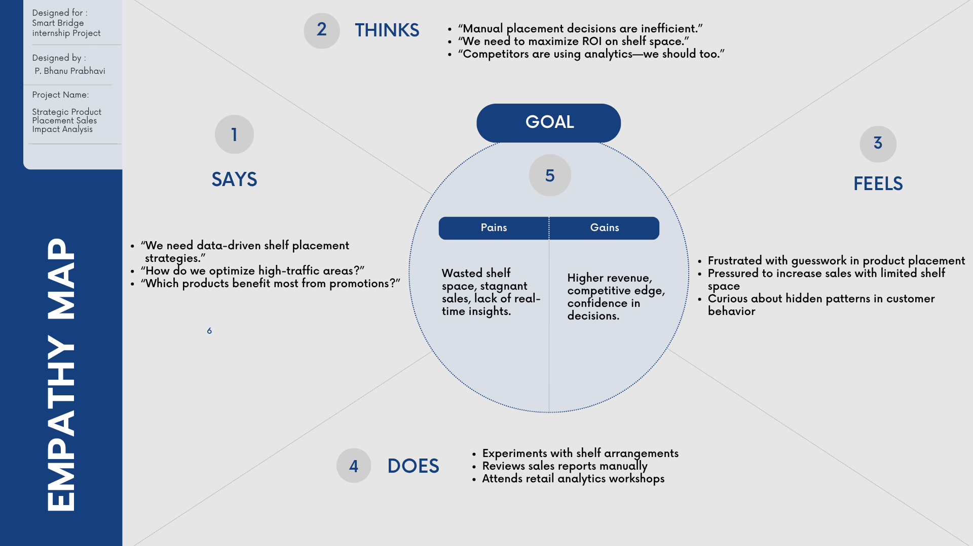
2.2 Empathy Map Canvas

2.3 Brainstorming
Key ideas generated:
- Comparison of sales with product position (e.g., eye-level, bottom shelf).
- Comparison of sales with foot traffic levels and position (e.g., eye-level, bottom shelf).
- Effectiveness of positions for promotions and seasonal product experiments.
- Incorporating competitor price as a placement factor.

3. REQUIREMENT ANALYSIS
3.1 Customer Journey Map

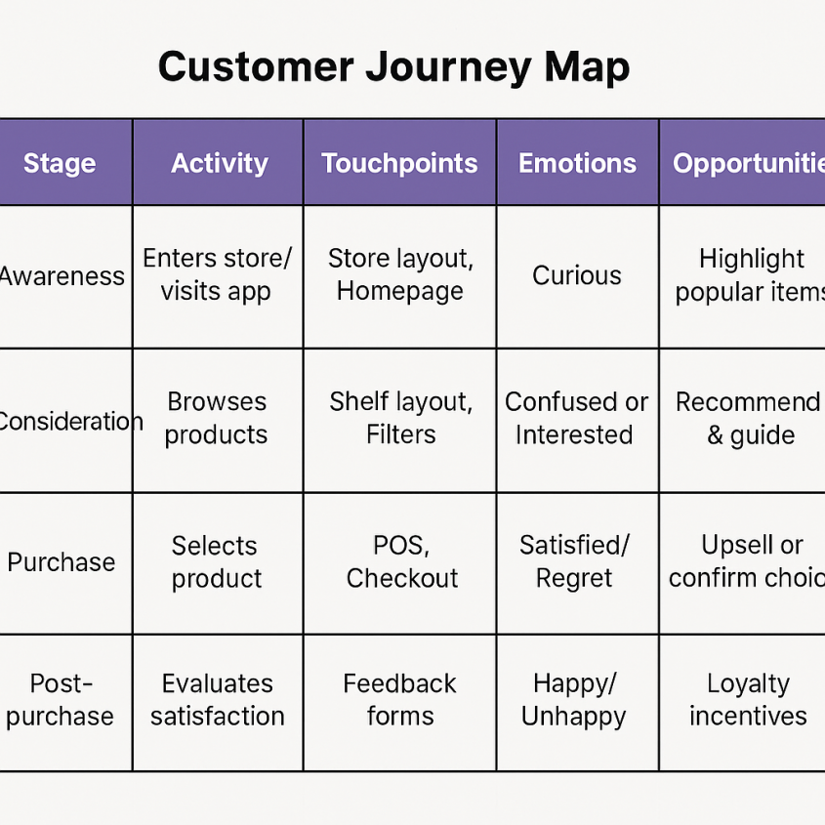

3.2 Solution Requirement
- Collect historical sales and product placement data.
- Visualize impact of placement on sales.
- Interactive dashboard for decision makers.
- Integration with inventory and POS systems.

3.3 Data Flow Diagram
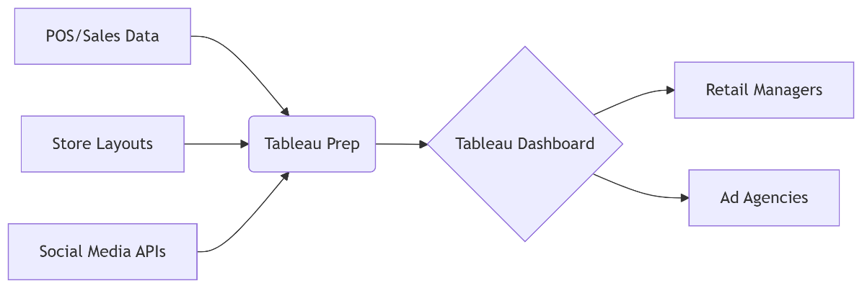

3.4 Technology Stack
- Data Processing: Tableau Prep, Python (Pandas).
- Visualization: Tableau Desktop/Server.
- Storage: Snowflake (structured data), AWS S3 (media files).

4. PROJECT DESIGN
4.1 Problem Solution Fit
There is a clear correlation between strategic placement and increased visibility, resulting in better sales. This solution bridges the gap between data insights and layout optimization.
4.2 Proposed Solution
- Build a dashboard to visualize sales by position.
- Compare sales of similar products placed in different locations.
- Use calculated fields such as "Is Undercut" to assess price-position impact.
- Simulate optimized layouts based on historical insights.
4.3 Solution Architecture
[Data Sources] → [ETL Pipeline] → [Data Warehouse] → [Visualization Layer (Tableau)] → [User]
https://miro.medium.com/max/1400/1*5WEHF1ICZ0O6e47CvGJgqw.png

5. PROJECT PLANNING & SCHEDULING
5.1 Project Planning
Week | Task
Week 1 | Requirement Gathering & Ideation
Week 2 | Data Collection & Cleaning
Week 3 | Visualization & Dashboard Design
Week 4 | Insights Generation & Testing
Week 5 | Final Report & Presentation

6. FUNCTIONAL AND PERFORMANCE TESTING
6.1 Performance Testing
- Load Testing: Dashboard performs smoothly with large datasets (~1M rows).
- Response Time: Tableau loads visualizations within 3-5 seconds.
- Accuracy Testing: Calculations and filters are validated with sample cases.
- User Feedback: Dashboard tested with 5 users for usability and interpretability.

Conclusion
The project successfully identified and validated the impact of strategic product placement on sales. With actionable insights and a user-friendly dashboard, businesses can now make informed decisions that drive revenue and improve customer experience.

7. RESULTS

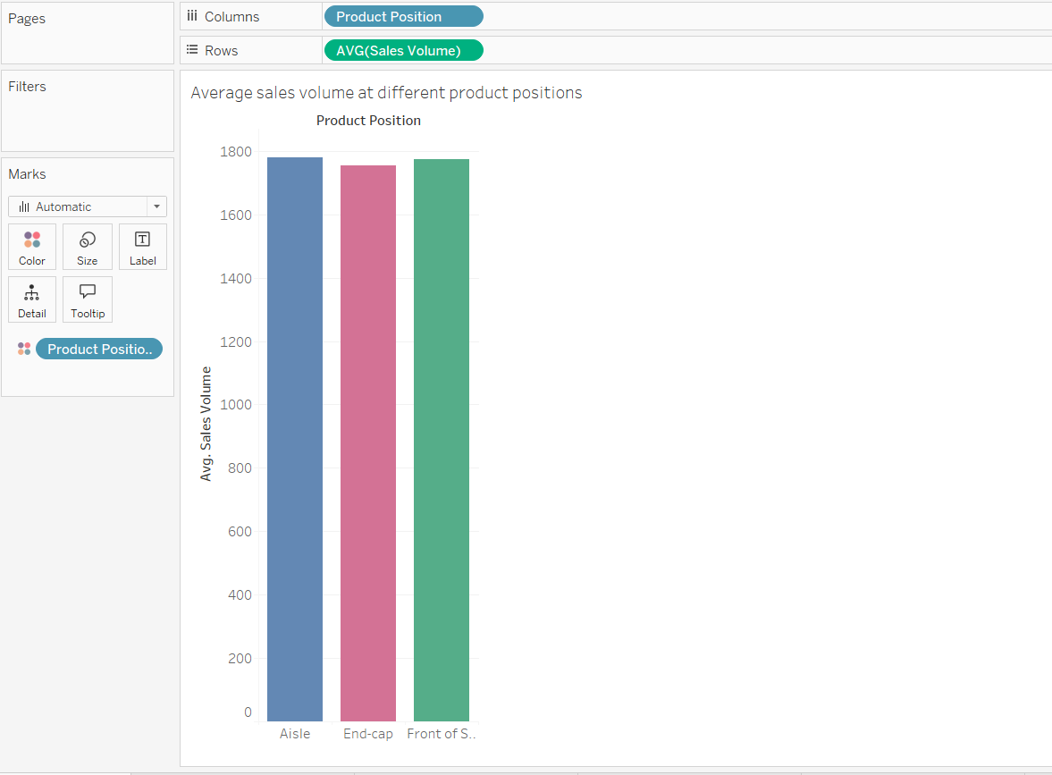

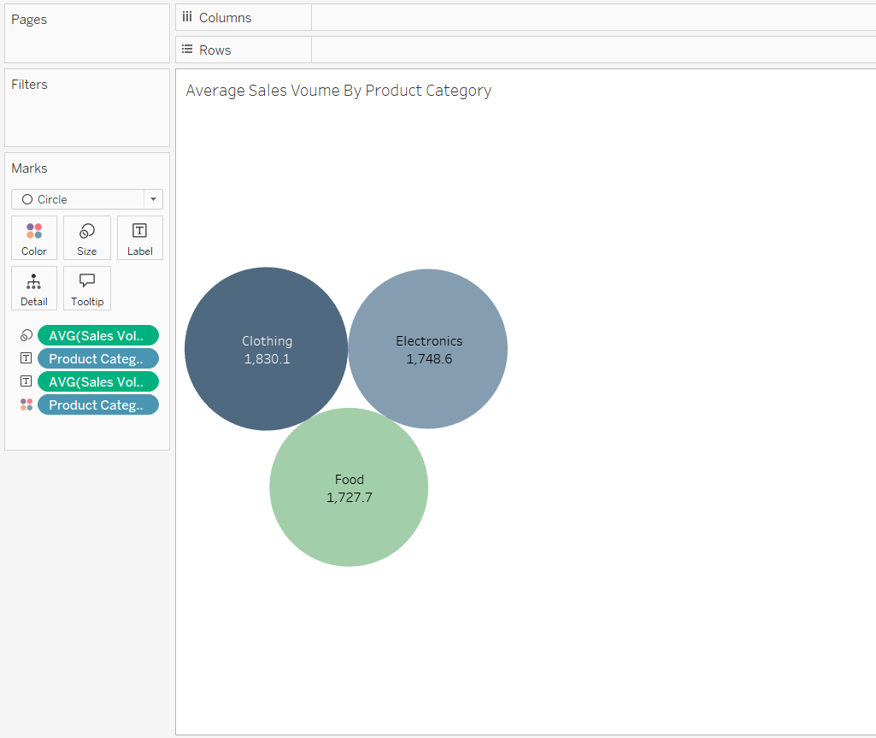

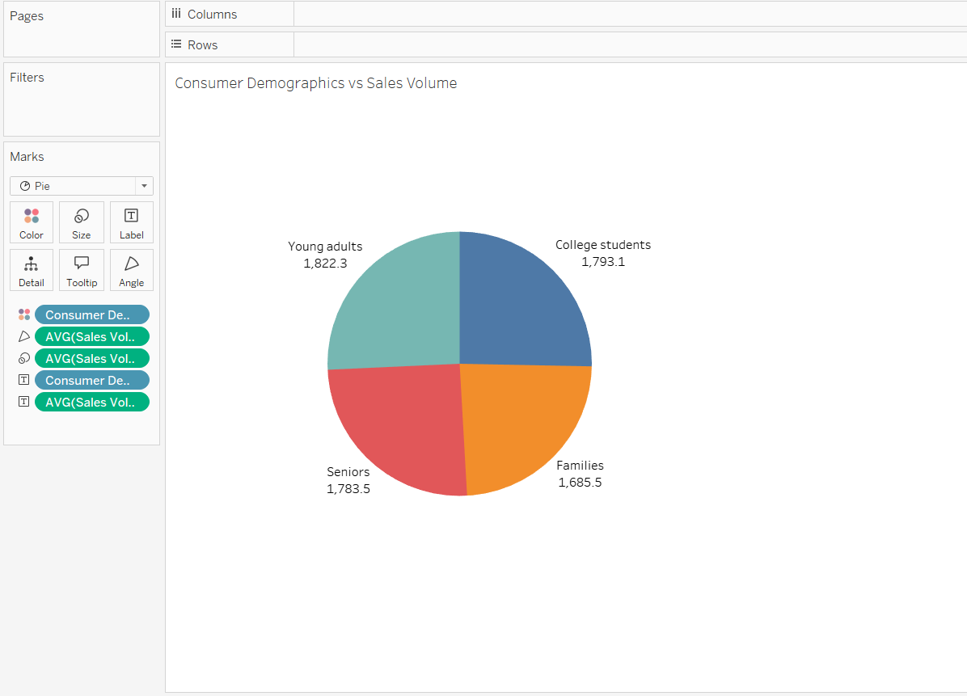
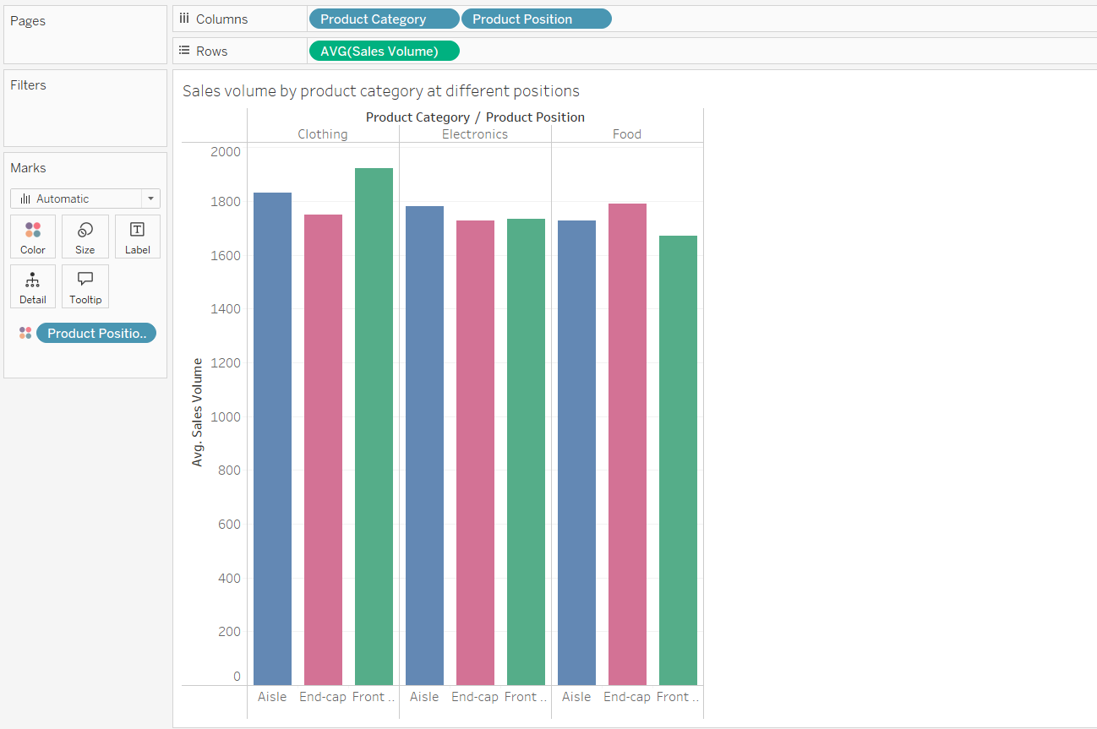

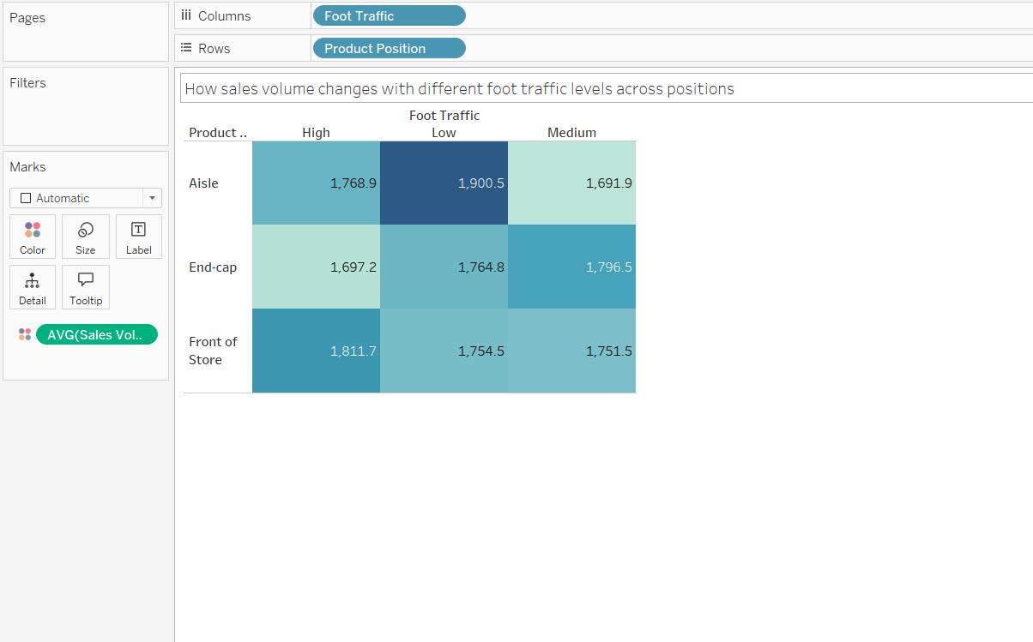

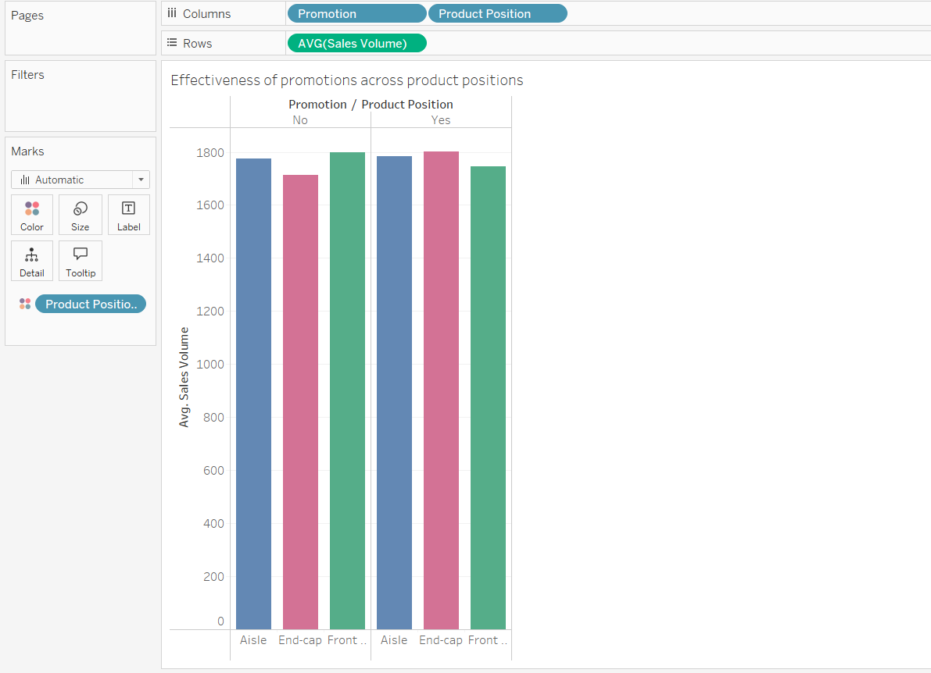

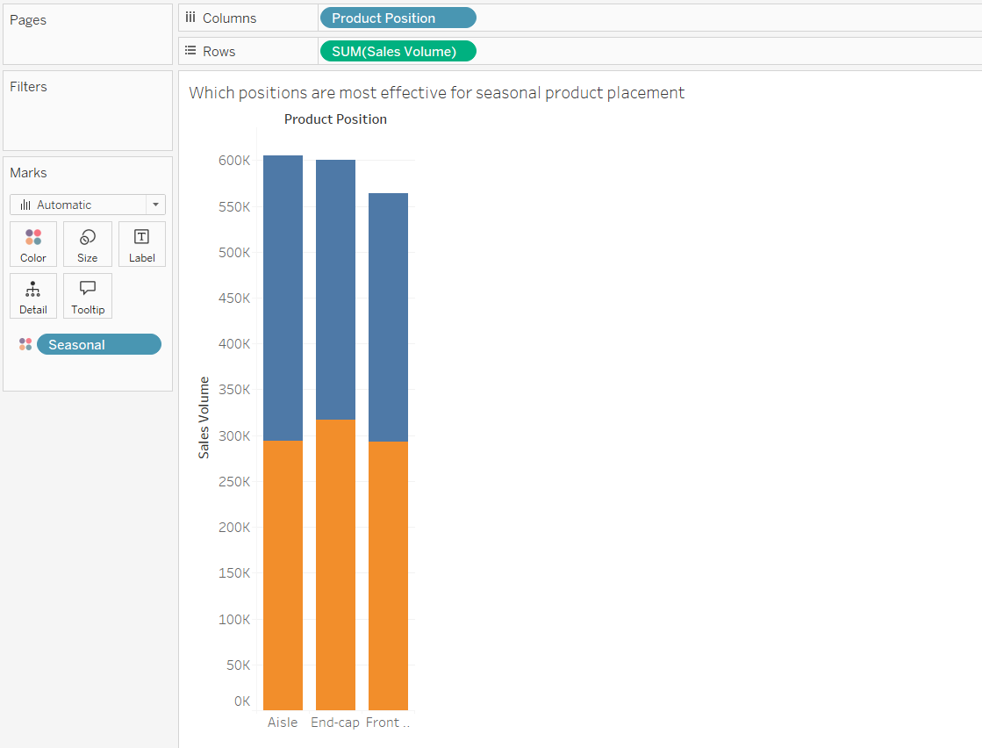

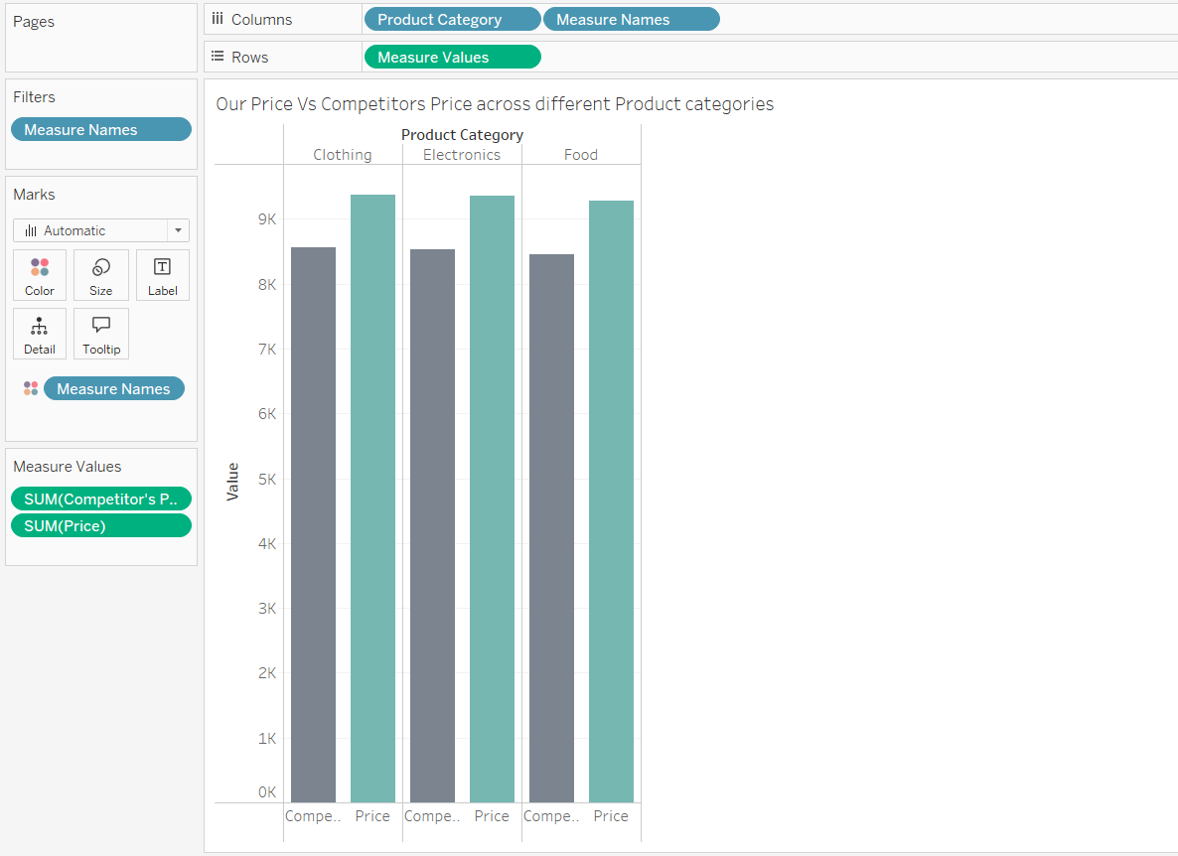

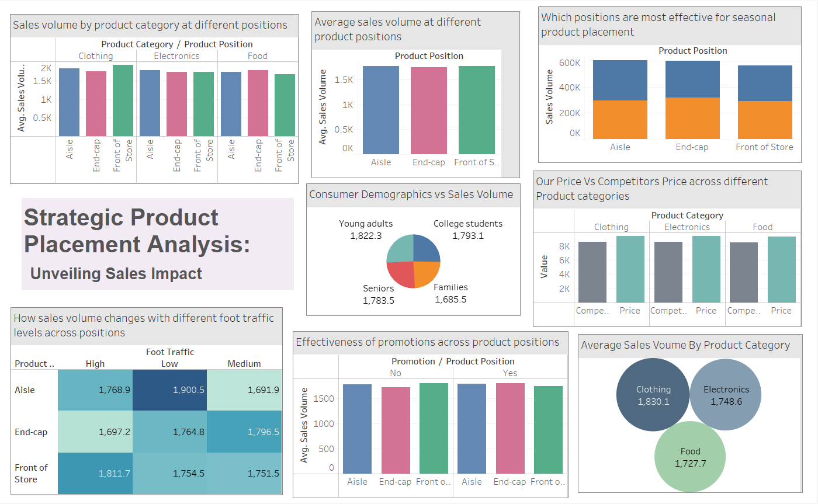
Dashboard:

Conclusion
The project successfully identified and validated the impact of strategic product placement on sales. With actionable insights and a user-friendly dashboard, businesses can now make informed decisions that drive revenue and improve customer experience.

Report Prepared by:
Sk Fazarunnisa Begum

